**SQL** **(Structured Query Language) is a query language to communicate with database**

**Server -> Data Import ‘world db.sql’**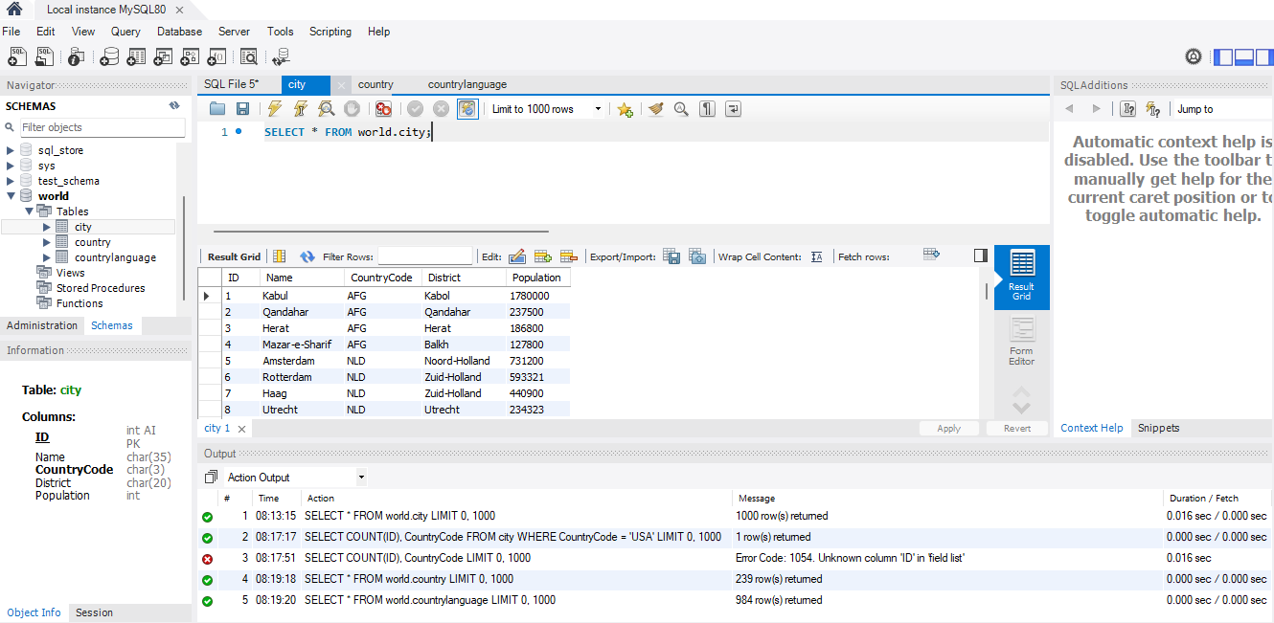

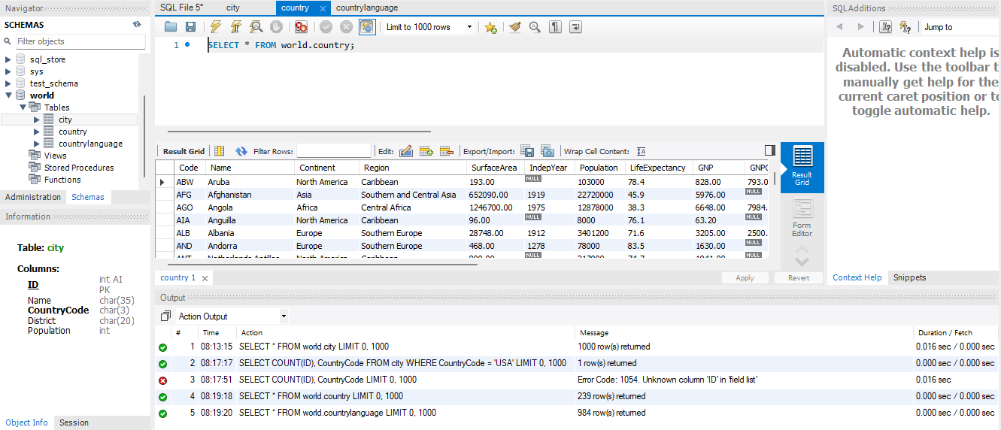

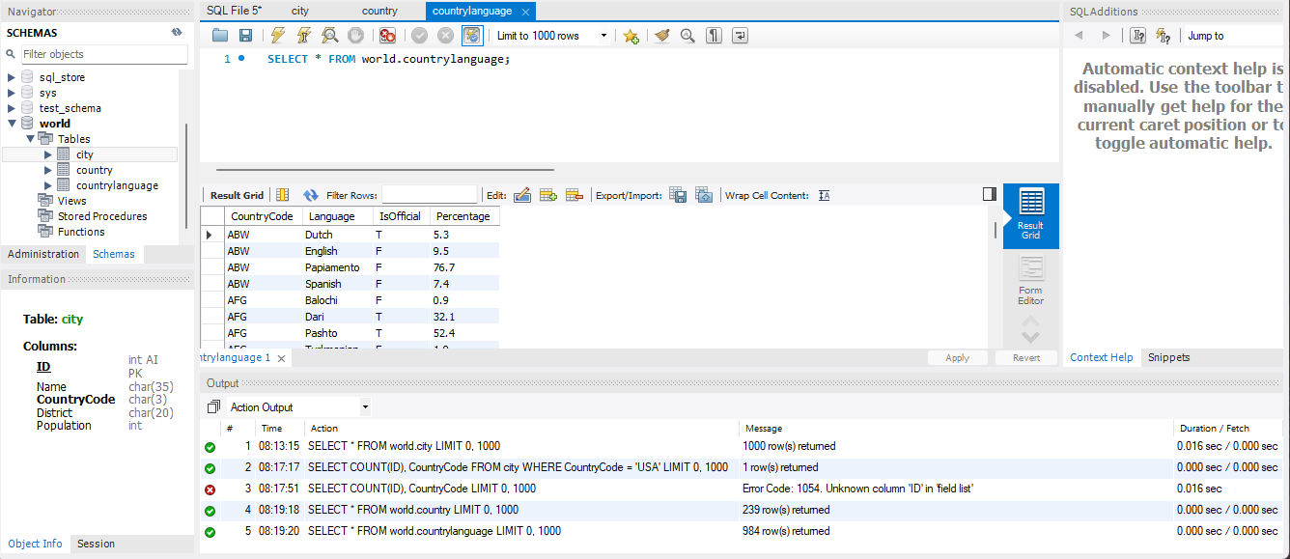

**Task 1:**

**Using COUNT, get the number of cities in the USA**

SELECT COUNT(ID), CountryCode

FROM city

WHERE CountryCode = 'USA';

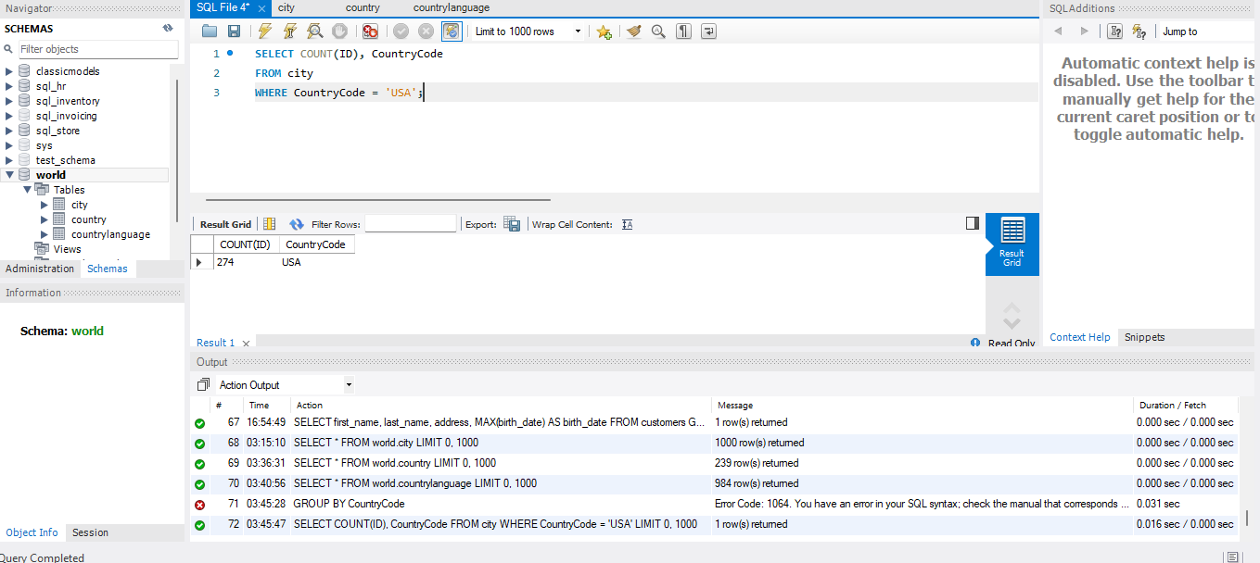

**Task 2:**

**Find out what the population and average life expectancy for people in Argentina (ARG) is.**

SELECT Name, Population, LifeExpectancy

FROM country

WHERE Name = 'Argentina';

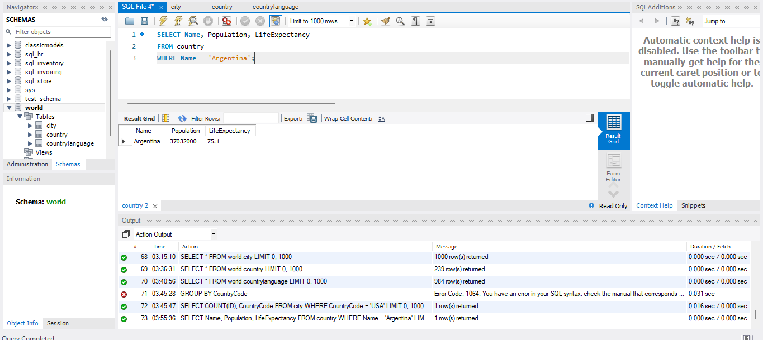

**Task 3:**

**Using ORDER BY, LIMIT, what country has the highest life expectancy?**

SELECT Name, MAX(LifeExpectancy) AS Highest_Life_Expectancy

FROM country

GROUP BY Name

ORDER BY Highest_Life_Expectancy DESC

LIMIT 1;

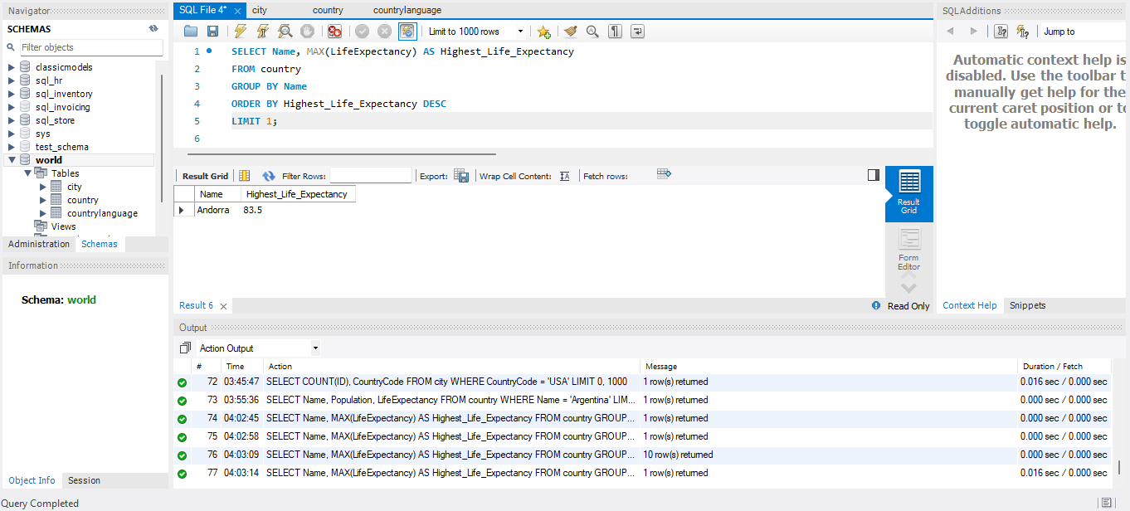

**Task 4:**

**Select 25 cities around the world that start with the letter 'F' in a single SQL query.**

SELECT * FROM city

WHERE Name LIKE 'F%'

LIMIT 25;

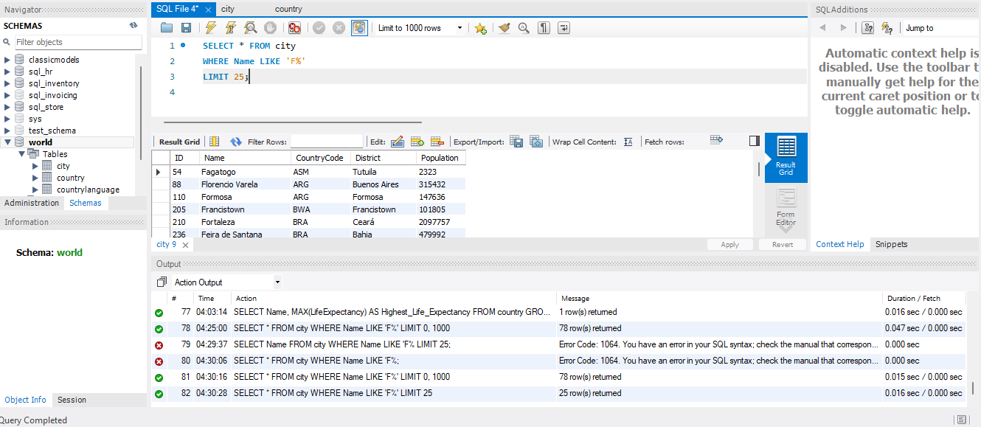

**Task 5:**

**Create a SQL statement to display columns Id, Name, Population from the city table and limit results to first 10 rows only.**

SELECT ID, Name, Population

FROM city

LIMIT 10;

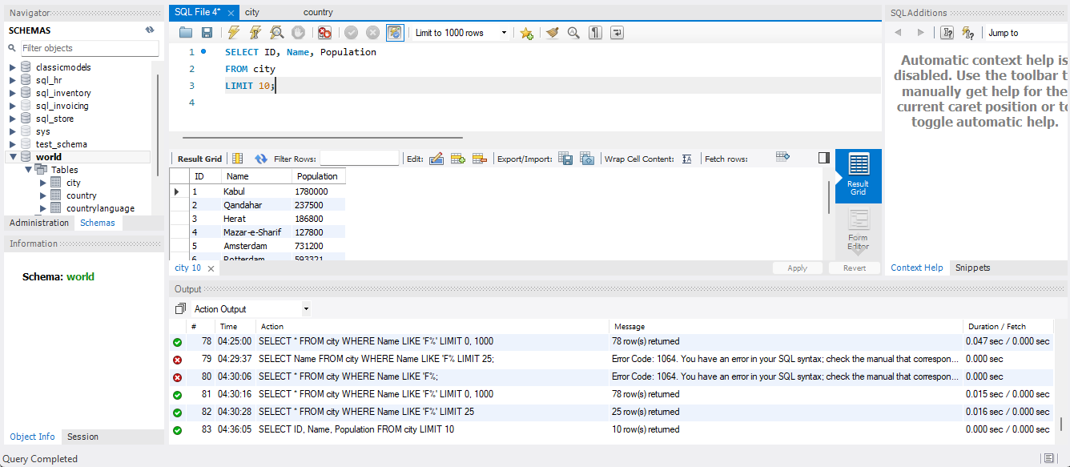

**Task 6:**

**Create a SQL statement to find only those cities from city table whose population is larger than 2,000,000.**

SELECT *

FROM city

WHERE Population > '2000000';

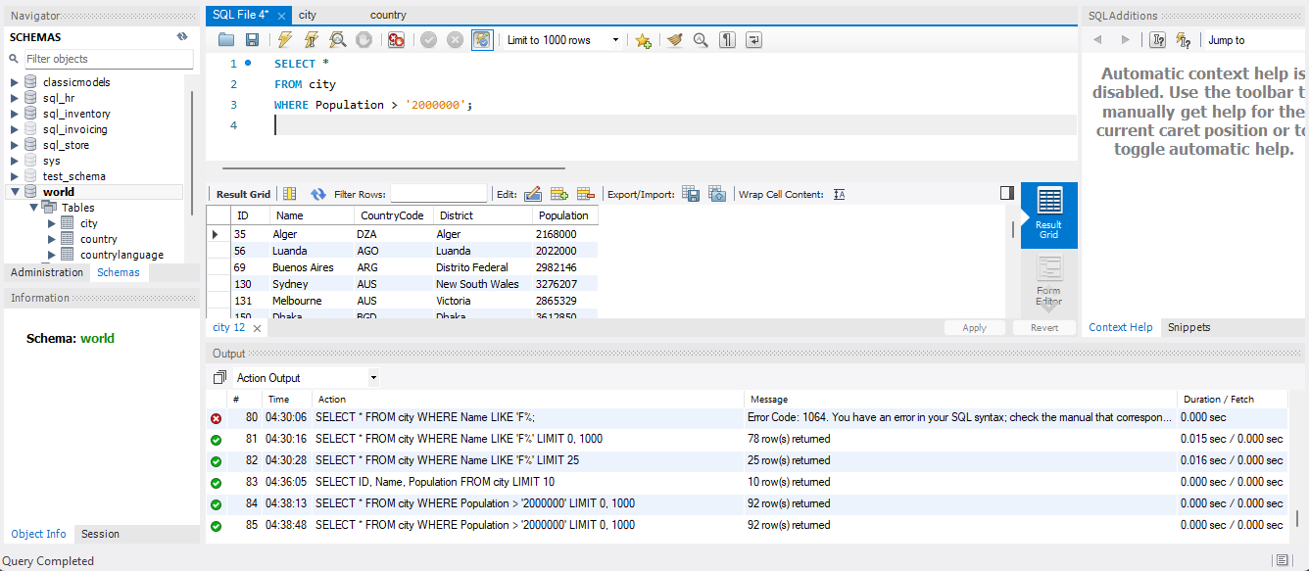

**Task 7:**

**Create a SQL statement to find all city names from city table whose name begins with “Be” prefix.**

SELECT * FROM city

WHERE Name LIKE 'Be%';

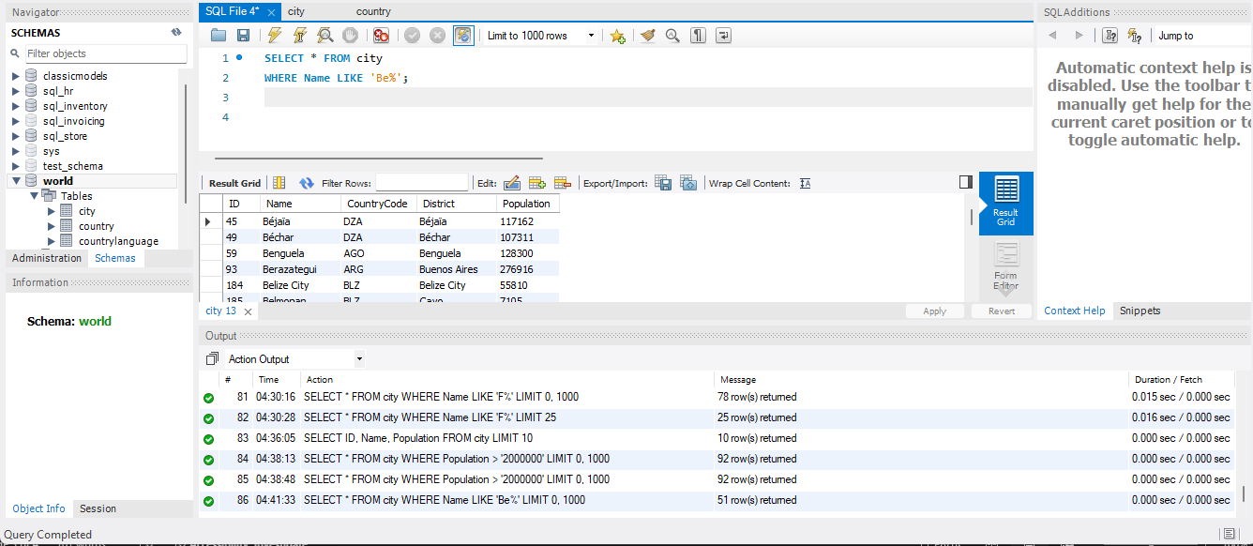

**Task 8:**

**Create a SQL statement to find only those cities from city table whose population is between 500000-1000000.**

SELECT * FROM city

WHERE Population BETWEEN 500000 AND 1000000;

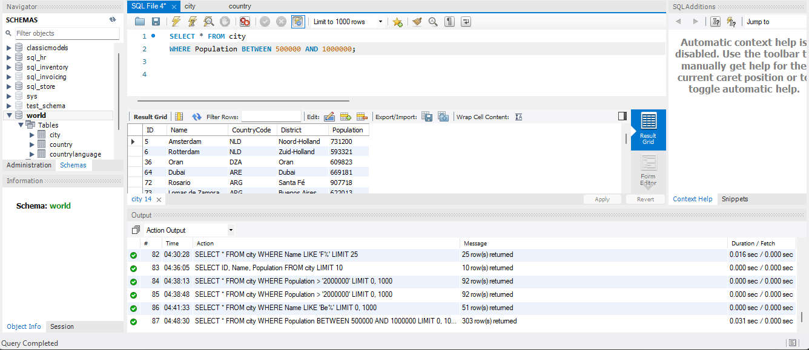

**Task 9:**

**Create a SQL statement to find a city with the lowest population in the city table.**

SELECT Name, MIN(Population) AS Lowest_Population

FROM city

GROUP BY Name

ORDER BY Lowest_Population ASC

LIMIT 1;

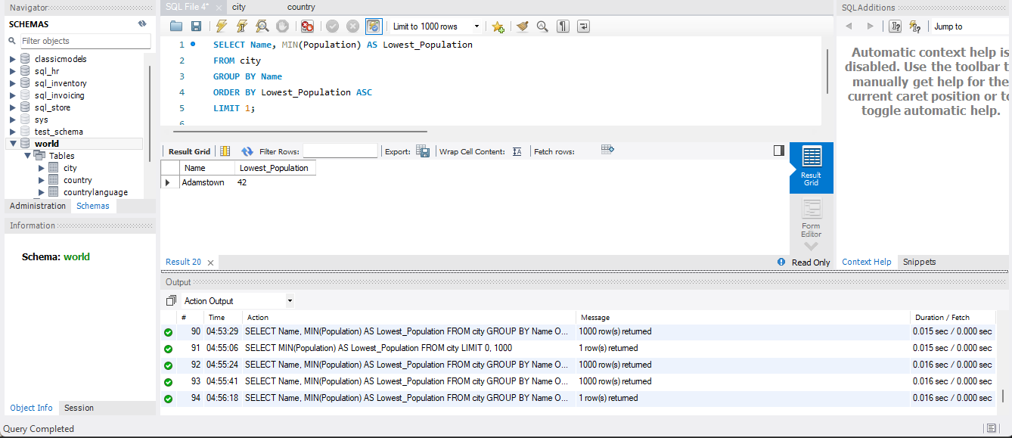

**Task 10:**

**Create a SQL statement to find the capital of Spain (ESP).**

SELECT Name, Capital

FROM country

WHERE Name = 'Spain';

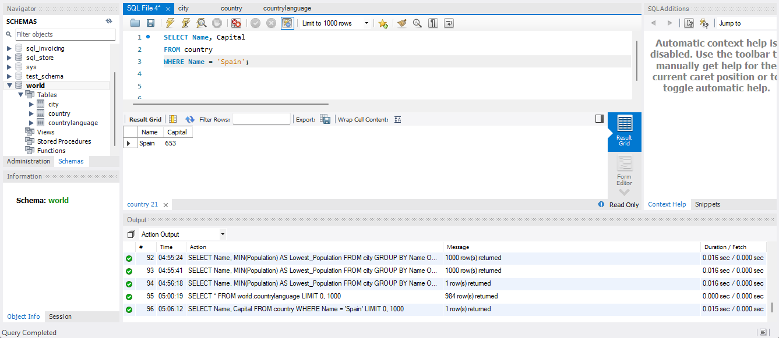

**Create a SQL statement to list all the languages spoken in the Caribbean region.**

SELECT Country.Code, Country.Region, countrylanguage.CountryCode, countrylanguage.Language

FROM country

CROSS JOIN countrylanguage

WHERE Country.Region = 'Caribbean';

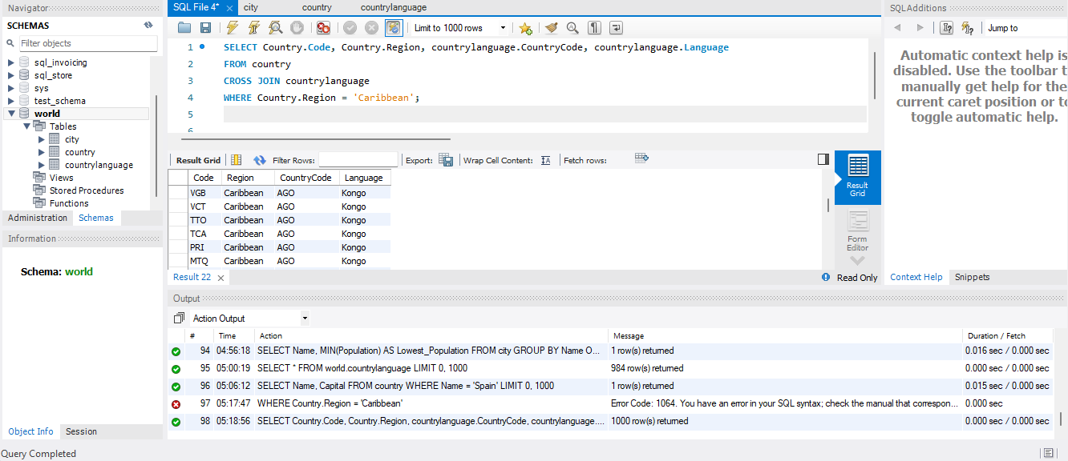

**Create a SQL statement to find all cities from the Europe continent.**

SELECT city.Name, country.Code, country.Continent

FROM city

CROSS JOIN country

WHERE country.Continent = 'Europe';

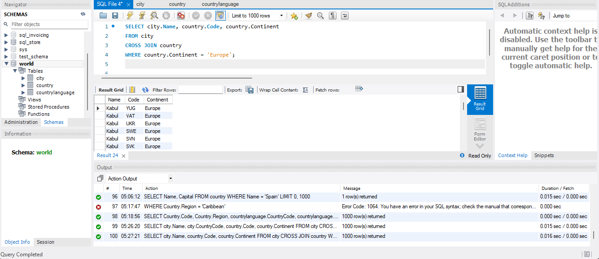

**EER Diagram:**

